20230421 計算機實習Practice 10

**題目：**

這次的作業希望你們使用**JavaFX**簡單寫出一個視窗。

**題目要求：**

幫我畫出一個矩形(顏色、邊長等等請隨意)

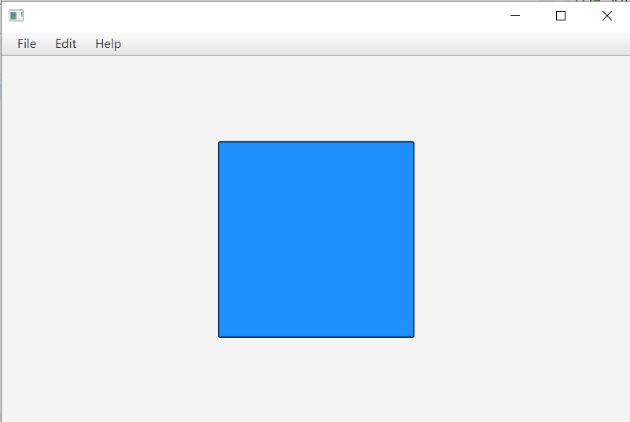

**補充說明：**

GUI程式需要人工批改，請將整個Project壓縮成zip並繳交到eeclass

**評分標準：**

For each input (test data) file, your program must produce an output file with a content that is EXACTLY THE SAME AS the expected output. This is the only way your program can "pass" any particular test.

In general, we will use 5 test data to test your project. The total score of this project is 100 points, and each test data accounts for 20%.